Virtual Continuing Education Event

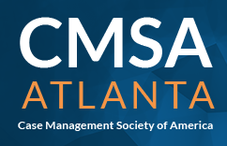
Management of Workplace Bullying in Healthcare:
Tactical and Ethical Guidance for Professional Case Management

Date: Tuesday, August 15, 2023 Time: 6:00-7:30 PM
Register at:
https://cmsa-atlanta.org/meetinginfo.php
Access URL will be sent to all registered attendees

Attendees will be entered into a drawing for the new book:
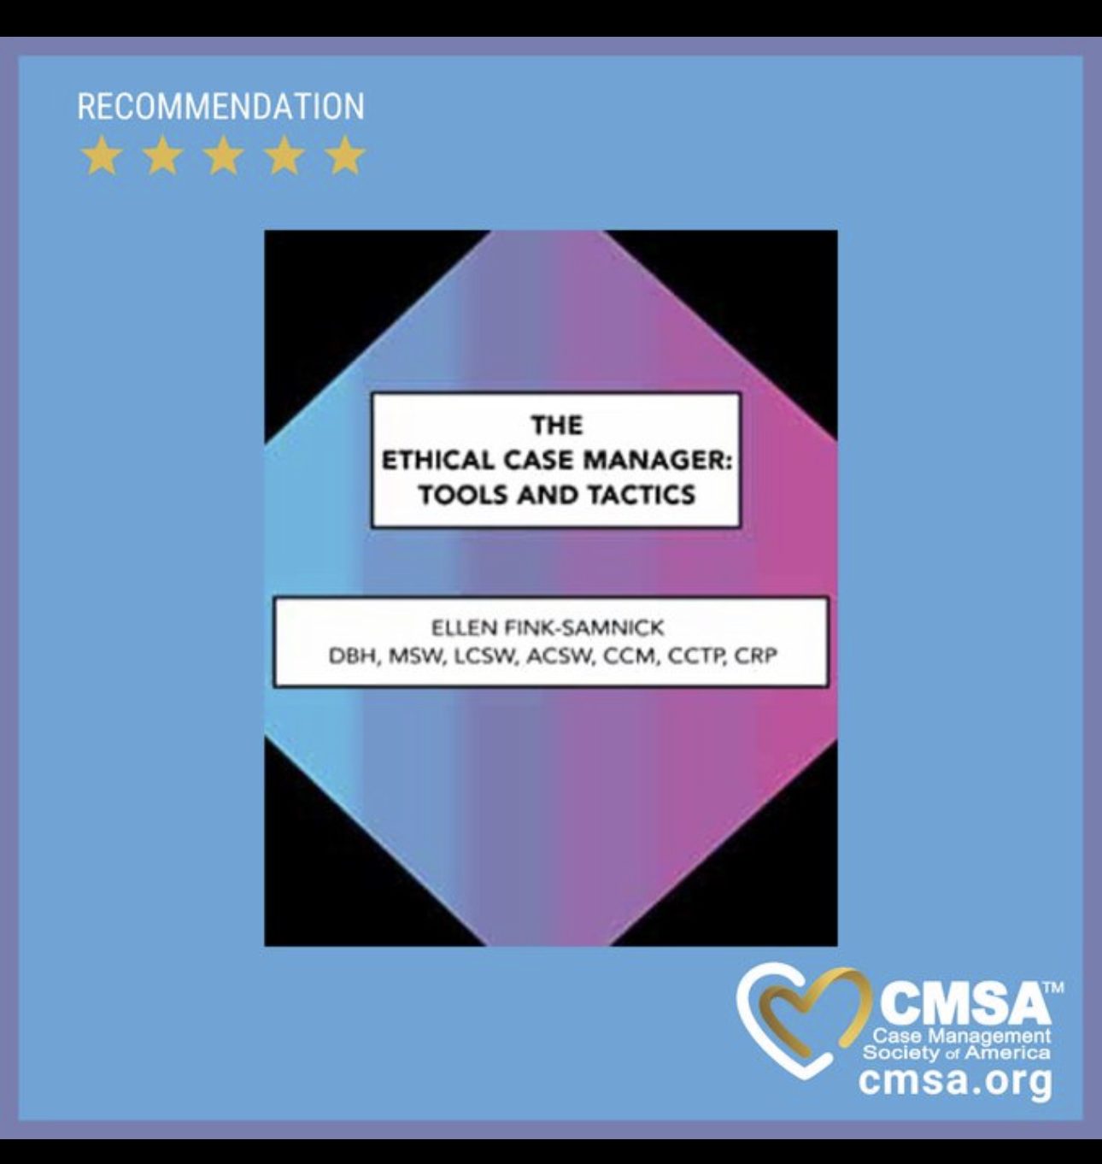

Contacts: Quanhong, Qiuccho

CMSA-Atlanta Members: Free National CMSA Members: Free
Non-Members: $25.00

Interested in becoming a CMSA member?
Please visit https://cmsa.org/membership/
Continuing Education Units:
- 1.25 Ethics CE’s pre-approved via the Commission for Case Manager Certification
- 1.0 Nursing, Physical Therapy, and Social Work CEUs pre-approved via Altra Healthcare Consulting, as a sponsor of CEUs for the state of Illinois

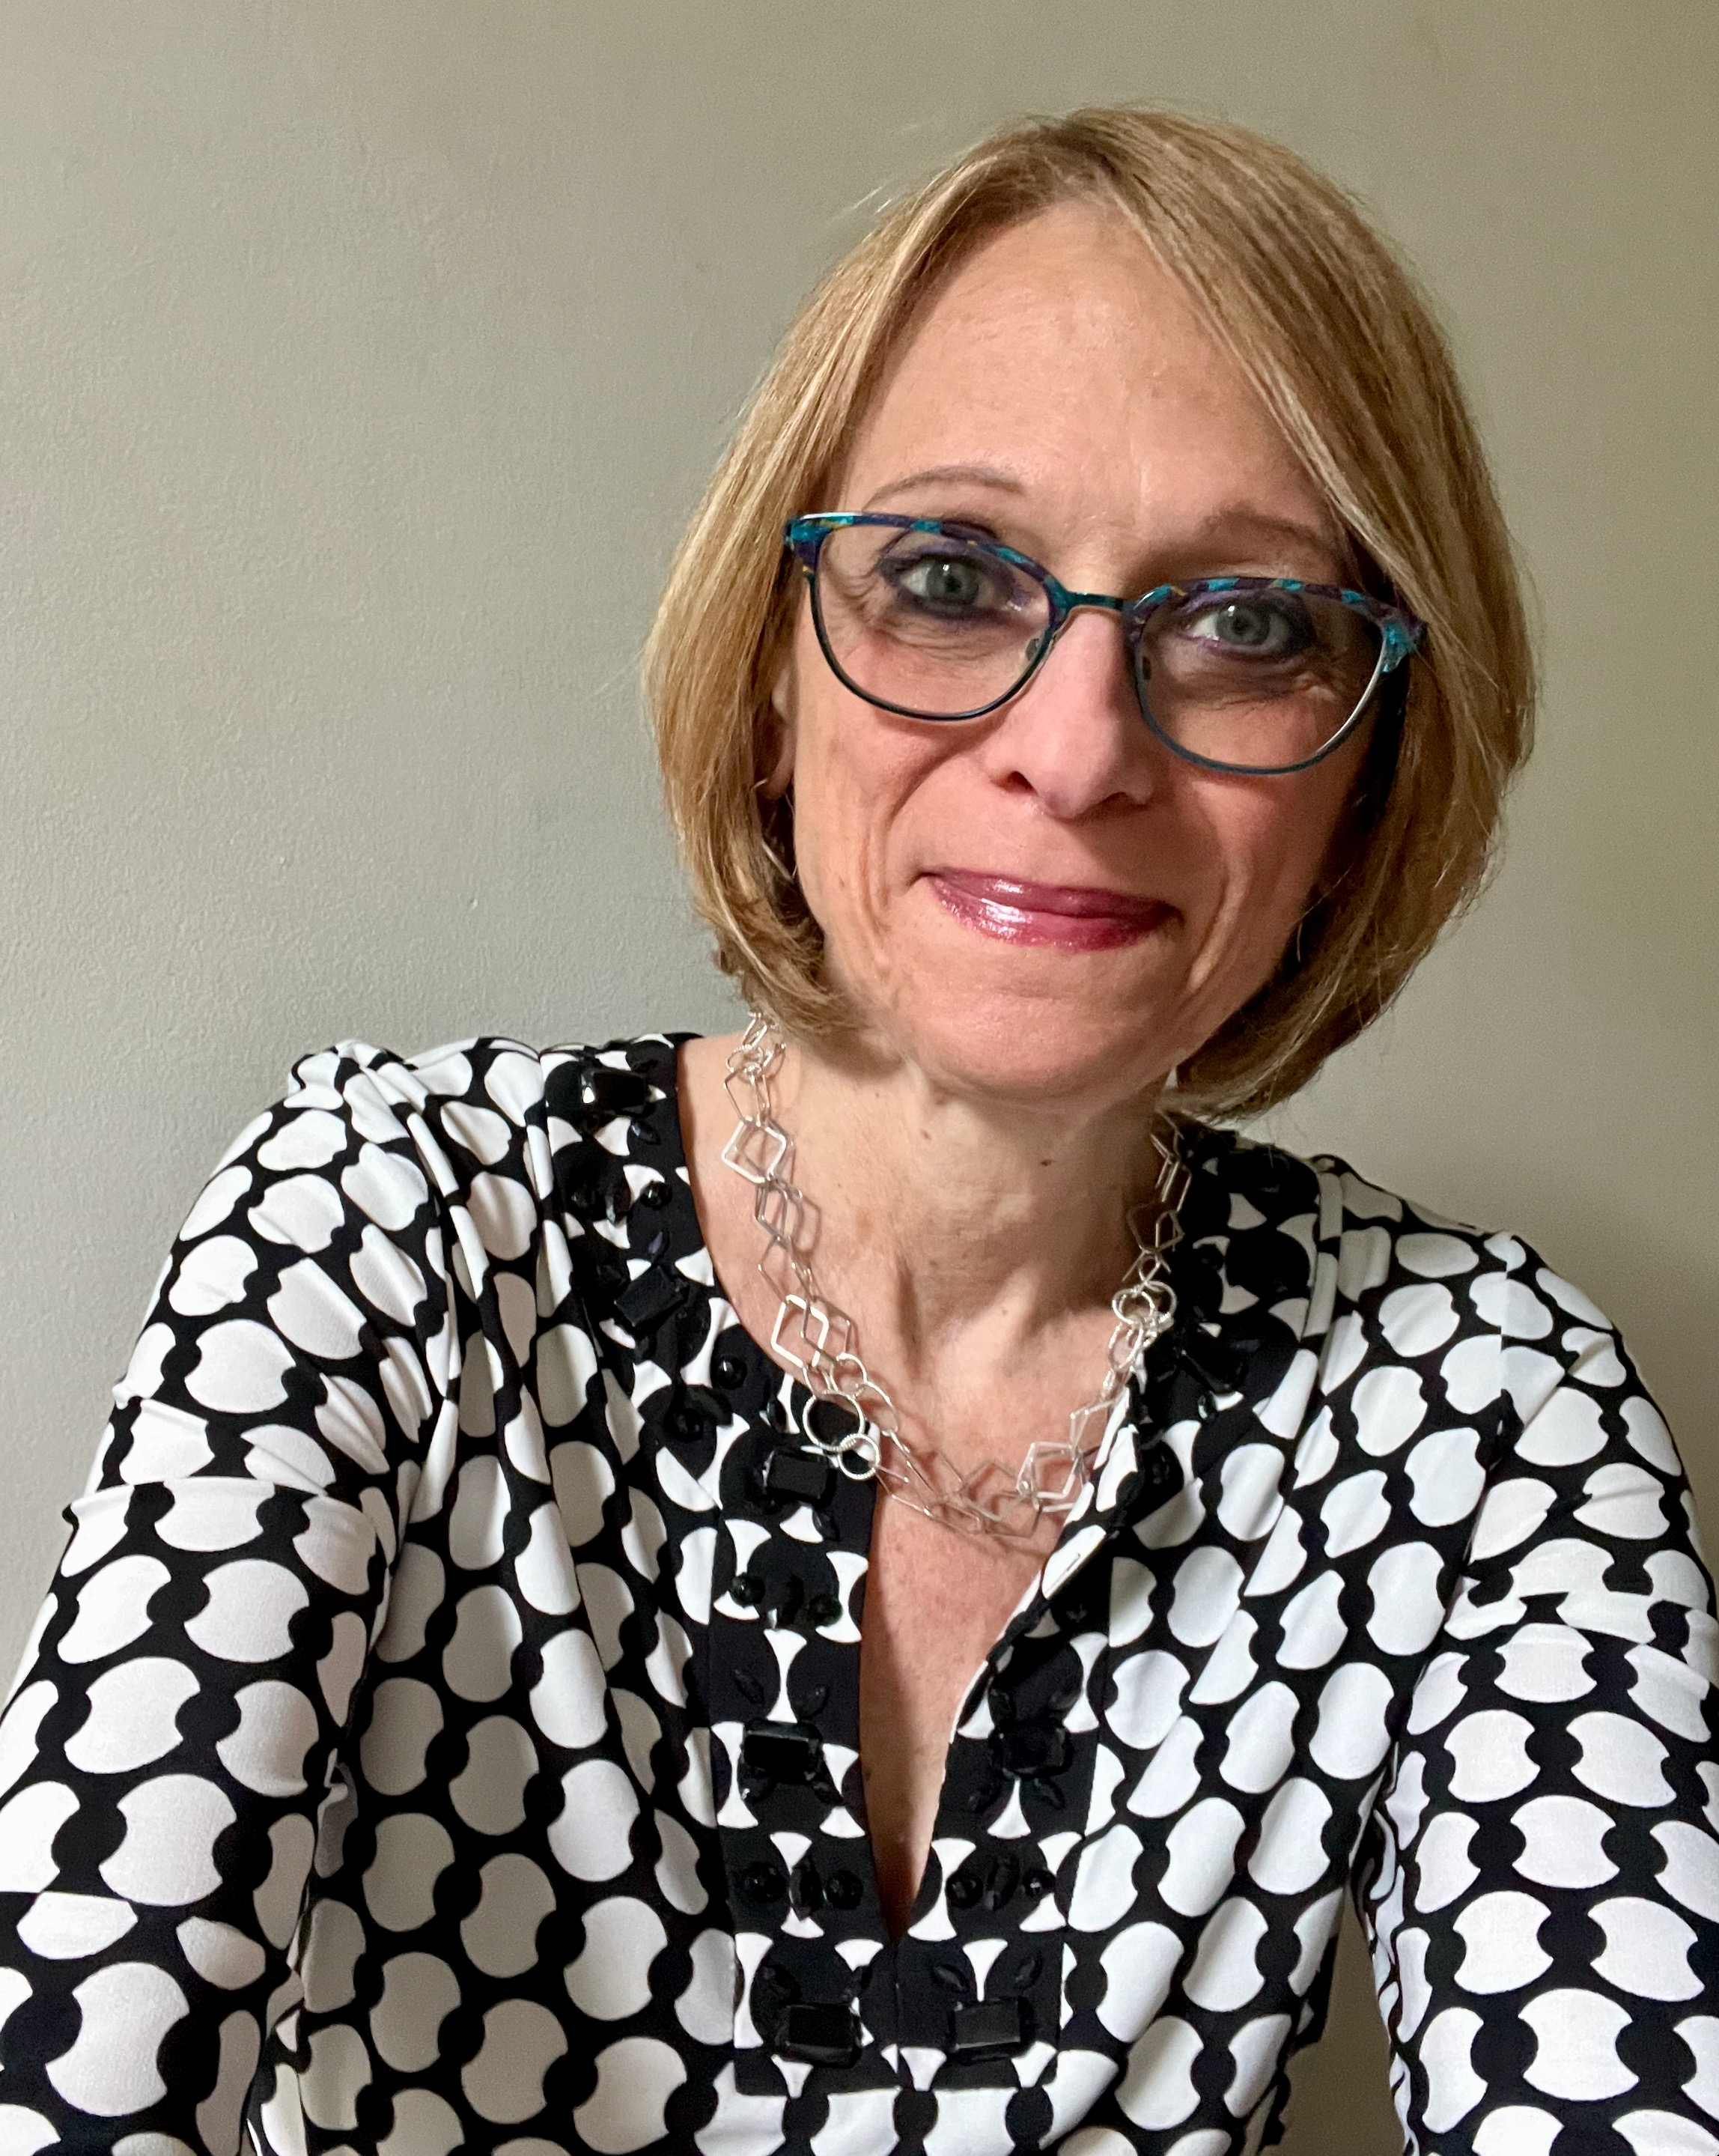
Presenter: Dr. Ellen Fink-Samnick DBH, MSW, LCSW, ACSW, CCM, CCTP, CRP, FCM
Principal of EFS Supervision Strategies, LLC

Dr. Fink-Samnick is an award-winning industry entrepreneur who empowers healthcare's interprofessional workforce. She is a subject matter expert on Ethics, Health Equity and Quality, Integrated Care, Interprofessional Teams, Professional Case Management, and Trauma-informed Leadership. Dr. Fink-Samnick is the author of a number of professional titles including the recently published The Ethical Case Manager: Tools and Tactics, The Social Determinants of Health: Case Management’s Next Frontier and End of Life Care for Case Management.
Dr. Fink-Samnick has a Doctorate in Behavioral Health with specialization in Health Equity, Integrated Care, Quality, Leadership, and Trauma-Informed Practice. She is a Licensed Clinical Social Worker, Board-certified Case Manager, and Certified Clinical Trauma Professional. Dr. Fink-Samnick has been inducted as a Fellow in Case Management as well as a member of the academic honor society, Delta Epsilon Tau.
Dr. Fink-Samnick serves the industry through a variety of roles with academic appointments at Cummings Graduate Institute of Behavioral Health Studies, George Mason University’s College of Public Health, and the University of Buffalo School of Social Work. She is a clinical supervision trainer and instructor for the National Association of Social Workers of Virginia and Metro DC, SDoH/Health Equity Strategist for Rise Association, moderator of Ellen’s Ethical LensTM on LinkedIn, and author of the blog, Ellen’s Interprofessional Insights. She is also a consultant for the Case Management Institute and moderator of their Case Managers Community.
Dr. Fink-Samnick is known for her fierce professional voice. Along with leadership and committee roles across credentialing entities and professional associations, she has served on the Gravity Project and the National Coalition for Social Work and Health. She is a board consultant to the American Association of Doctors of Behavioral Health and an editorial board member for the Professional Case Management Journal, and Case Management Monthly. Further information is available on her LinkedIn Profile.
REQUIRED: In order to obtain your CE Certificate, you must attend the session in its entirety, complete the attendance roster, and online evaluation. Your CE certificate will be emailed within one week of the event.

